
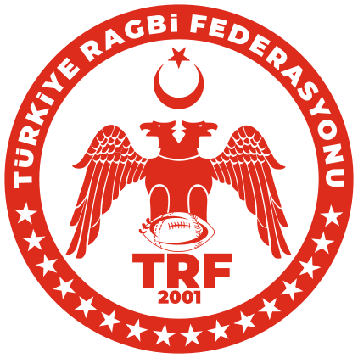

2026 7'li Ragbi Kadınlar Olimpik Sporcu Listesi

AD SOYAD
1 SEDANUR B***T
2 BERİVAN D***Ç
3 SEDANUR A****Z
4 GAMZE A***Y G****N
5 NAZLICAN E******N
6 AYÇA A******R
7 VAHİDE K******N G****Ç
8 HİLAL K*****Z
9 TUĞÇE N***Y F***İ
10 SELİNAY A*****A
11 TUĞBA N*R Y***Z
12 EBRAR A***N
13 GÜLNUR S*K
14 AYTEN A******I
15 EBRAR B***E Y******A
16 MELİKE T******A
17 RÜMEYSA Ç***K
18 RAZİYE Ş****K
19 RAVZA N*R A***L
20 SAİME Z****P A***N
21 ŞURA U**U
22 SUDE Y*****R
23 HÜLYA T***I
24 GÜLBAHAR E****İ
25 ECEM N******E
26 ENNUR Ü**Ü
27 RABİA A*****N
28 PINAR Ö**Ü Y*******A
29 BERRA N*R Y**T
30 MELEK A*******Ş
31 ASİYE A***N
32 MELEK C***K
33 GAMZE G***Ç
34 BETÜL P***L
35 MERYEM Ş**K
36 NAZLI K******Z
37 MERYEM Y*****Z
38 ECMEL R**A Ç***R
39 NURGÜL A*******T
40 AYŞENUR Y****Z
41 İREM G*L G***L
42 ELİF Ö*****K
43 NEHİR T*K
44 MELİKE O******Y
45 SÜMEYYE S*******Z
46 EYLÜL K****L

