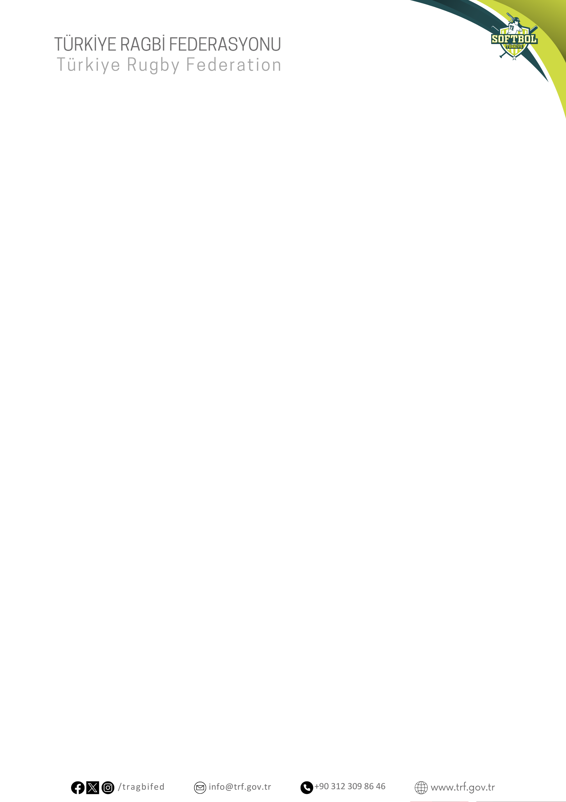

U22 SOFTBOL MİLLİ TAKIM SPORCU LİSTESİ

1. BÜŞRA B****Ğ
2. HİRANUR S*R
3. HİLAL I***K
4. SUDE N*Z T****N
5. HAYEL D*******N
6. NİSA G******K
7. SEVDA C****N
8. HANDE A**R
9. YASEMİN Ç****Z
10. DİLA B**Kİ
11. MELEK N*R B***N
12. AYŞENUR E*E
13. ELİF Ç***A G***Ü
14. NİHAL G****N
15. DENİZ D***R
16. RAVZA R***A

